INERTIA BALANCE

Inference : The period of the loaded jigsaw blade is depend on the mass of the loaded jigsaw blade

Hypothesis : When the mass of the load increase, the period of vibration increase

Aim : To investigate the relationship between the mass of the load and period of oscillation

Manipulated variable: mass of load

Responding variable: period of vibration

Fix Variable: length of jigsaw blade

Apparatus : G-Clump, loaded mass, jigsaw blade and stop watch

Procedure

1. Setup the apparatus as diagram above

2. The loaded mass for 10g is stick to the jigsaw blade.

3. The jigsaw blade is deflected down and released

4. The time for 20 vibration of the spring, t is recorded by using stop watch

5. Period of vibration is calculated by t/20

6. The experiment is repeated by using the mass of load for 20g, 30g,40g and 50g

Tabulating Data

|  |  |  |  |
| --- | --- | --- | --- |
|  |  |  |  |
|  |  |  |  |

Conclusion

T2 is directly proportional to mass.

T2 is linearly increase to mass.

Precaution

The angle of deflection is less 8°

**CENCO Inertia Balance**

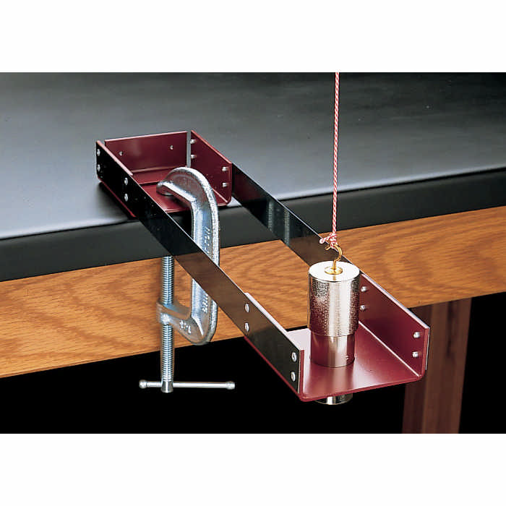

Distinguishing inertial from gravitational mass can be confusing, but this robust inertial balance can reduce that confusion and provide an accurate measure of inertial mass for any object between 100 and 600g. With the included “unknown” slug, machined to fit snugly in the hole on the balance platform, one can show how inertial mass is wholly independent of gravity. The balance is comprised of two metal platforms connected by a pair of spring steel blades mounted with their flat sides vertical. Once one platform is securely clamped to a tabletop, the other can oscillate freely in a horizontal plane. After calibrating the balance with known masses by measuring their periods, students can measure the inertial mass of the “unknown” slug, both when resting in the balance platform and while suspended from a cord. The “unknown” slug has a machined shoulder to fit the balance platform and a hook from which it can be suspended. The balance is 10 x 35cm and comes with one unknown mass and complete instructions. In addition, you will also need five or six 2″ C-clamps, one 3″ or 4″ C-clamp, a stopwatch or clock with second hand and a support stand with a horizontal attachment.

**Description**

The inertia balance is designed for use in a laboratory experiment in which mass is quantitatively measured independent of the earth's gravitational force. This same method is used in determining the mass of an object under weightless conditions in space flights.

The apparatus consists of two small platforms connected by two horizontal, nonsagging, spring-steel blades. A cylinder with a shoulder on which it can rest in a hole in the platform and a hook by which it can be suspended are included. This cylinder may be used as an object of unknown mass.

**Instructions**

The apparatus is calibrated by determining the vibration frequency for several known platform loads, using the data obtained to plot a calibration curve. The vibration frequency of the balance is then determined with the unknown as the load and the mass of the unknown read from the calibration curve.

Securely clamp the inertia balance to a well-braced laboratory bench by means of a C-clamp. The platform with the hole should be used for supporting the load.

Use a stopwatch to determine the time for a given number of vibrations. Begin with a load of two 100 gram masses on the platform and determine the time for 100 vibrations. By using small amplitudes and waiting until several oscillations have occured before timing, there will be no slippage of the weights on the platform. Repeat, determining the time for 100 vibrations for loads of 3,4,5 and 6 weights.

Compute the period in seconds for each load and plot period against the weight of the corresponding load. Also, plot period squared against the corresponding load. Which curve is more nearly a straight line, and what conclusion can be drawn as to the relationship between mass and period?

Place the unknown mass in the hole of the platform and determine the period of the vibration. From the calibration curve, obtain the mass of the unknown and compare the value with that obtained by weighing the unknown on a balance.

**Parts**

Inertia balance

6-100 gram masses

Stopwatch

# Simplified Inertial Balance

# http://www.cencophysics.com/images/700/CP72701-41_EA.jpgThis is a must for your lab. An economical introduction to the concepts of inertial and gravitational mass; with it you can calculate the periodic motion produced by the two blades of the balance when it is pushed sideways and use it to show that gravity plays no role in its operation. This PSSC listed item contains two aluminum trays, one with a hole; two spring blades; one iron slug with a hole for threading; one base plate; nylon cord; and a detailed instruction manual. Size: 35.5 x 10cm.

**Cenco-Schriever Inertia Balance**

This demonstrates the effect of varying masses on the period of a vibrating system.

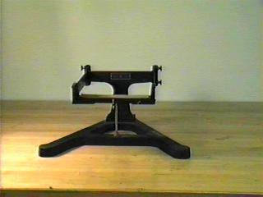

http://physics.kenyon.edu/EarlyApparatus/Mechanics/Inertia_Balance/Inertia_Balance.html

|  |  |
| --- | --- |
| When I came to teach at Kenyon in the fall of 1964, the first experiment used the inertia balance. Various masses were placed on the platform that was set into side-to-side oscillations, and the corresponding periods timed. A graph of the period as a function of mass was drawn, and then the students timed an unknown mass. Its period was then used to read the mass off the graph  It was an ideal first experiment -- the students did not have to know any theory, they learned something about timing operations, had a chance to graph some data and do some interpolation. Foolishly I replaced it in the next year. Today I would use it again. | http://physics.kenyon.edu/EarlyApparatus/Mechanics/Inertia_Balance/Kenyon207a.JPG |

http://physicslearning.colorado.edu/ldl/demo1F10.11#

[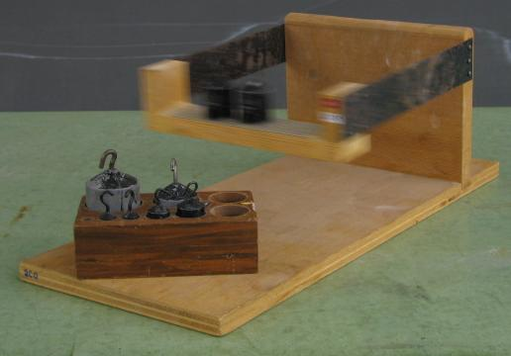](javascript:warp())

The inertia balance may be used to measure mass independent of gravity. Measure the period of the balance with a stop watch. Add known weights to the balance and measure the period each time. Plot on the blackboard the period squared versus mass. This will yield a straight line, and unknown masses may be determined by reading the graph when the period is known. The expression for T (the period) is: T^2 = (M+m)/k Where m and k are constants, and M is the mass added to the balance.